SkillSprint AI Project Report:

Architecture and data flow:
Flowchart > Left to Right
A [Admin PDF / DOCX upload] --> B [Type, size, duplicate, version validation]
B > > > > > > --> C [Parser and traceable chunks]
C > > > > > > --> D [Approved document register]
D > > > > > > --> E [Role Requirement Matrix]
F [Employee profile] > > > > > > --> G [Structured generation pipeline]
E --> G
G > > > > > > --> H [JSON onboarding plan]
H > > > > > > --> I [Independent Python validator]
E > > > > > >> --> I [Independent Python validator]
\<Loop into Mismatch>
D > > > > > > --> I [Independent Python validator]
I > > > > > > --> J [Verified / Warning / Manual Review]
J > > > > > > --> K [Dashboard, progress, CSV report]

Core use case:
An authorized administrator uploads a company policy, confirms its metadata, and approves it. A manager selects an employee. Generation returns JSON containing requirements, stages, sources, quiz source mappings and rubrics. Validation compares attributes - never exact prose - against the active matrix. The plan is released only with its resulting verification status.

Sequence:
Sequence Diagram:
participant M as Manager
participant W as Web app
participant G as Generator
participant V as Python validator
participant D as SQLite
M->>W: Select employee / generate
W->>D: Read active role matrix and sources
W->>G: Role + approved evidence
G-->>W: Structured JSON
W->>V: Plan + matrix + source metadata
V-->>W: Scores, issues, status
W->>D: Persist plan and report
W-->>M: Plan and verification evidence

Test checklist:
- Test | Expected result |
- PDF/DOCX upload | Stored, chunked and set Pending Review |
- Unsupported extension
- HTTP 400
- Duplicate title/version
- HTTP 409
- Prompt injection phrase Flagged as data
- Obsolete source Manual Review Required Missing mandatory requirement | Coverage below 100
- | Generated seed plan | Verified and 100% traceable |
- | CSV export | Plan validation evidence downloads
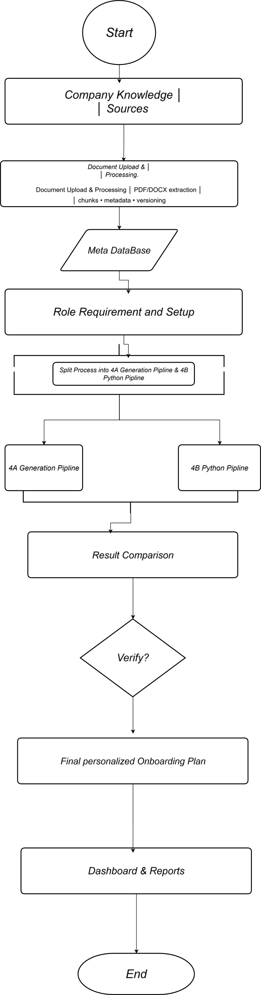
User Flow Diagram:

